[](https://www.mkce.ac.in/)

A Minor Project Report

on

**STUDENT AND STAFF FEEDBACK SYSTEM**

Submitted in partial fulfilment of requirements for the award of the

Degree of

**BACHELOR OF TECHNOLOGY**

in

**INFORMATION TECHONOLOGY**

Under the guidance of

**Ms.A.NITHIYA**

**ASSISTANT PROFESSOR/IT**

**Submitted by**

BOOPATHI M (927621BIT013)

JAGADHEESWARAN T (927621BIT037)

JANARTHANAN S (927621BIT039)

KISHORE B S (927621BIT053)

**DEPARTMENT OF INFORMATION TECHNOLOGY**

**M.KUMARASAMY COLLEGE OF ENGINEERING**

(Autonomous)

**KARUR – 639 113**

December, 2022

**M.KUMARASAMY COLLEGE OF ENGINEERING**

**VISION**

To emerge as a leader among the top institutions in the field of technical

education.

**MISSION**

* Produce smart technocrats with empirical knowledge who can surmount

the global challenges.

* Create a diverse, fully engaged, learner-centric campus environment to

provide quality education to the students.

* Maintain mutually beneficial partnership with our alumni, industry and

professional associations.

**DEPARTMENT OF INFORMATION TECHNOLOGY**

**VISION**

To create groomed, technically competent and skilled intellectual IT

Professional to meet the current challenges of the modern computing industry.

**MISSION**

* To ensure the understanding of fundamental aspects of Information

Technology

* Prepare students to adapt to the challenges of changing market needs by

providing an environment.

* Build necessary skills required for employability through career

development training to meet the challenges posed by the competitive

world

**PROGRAM EDUCATIONAL OBJECTIVE**

1. Solve real world problems using learned concepts pertaining to Information

Technology domain.

1. Encompass the ability to examine, plan and build innovative software

products.

1. Carry out the profession with ethics, integrity, leadership and social

responsibility.

**PROGRAM SPECIFIC OUTCOMES**

1. **Professional Skills**: Comprehend the technological advancements and practice professional ethics and the concerns for societal and environmental well-being.
2. **Competency Skills:** Design software in a futuristic approach to support current technology and adapt cutting-edge technologies.
3. **Successful career:** Apply knowledge of theoretical computer science to assess the hardware and software aspects of computer systems.

**PROGRAM OUTCOMES**

**Graduates of Bachelor of Information Technology will have the following ability and capability at the end of course:-**

1. **Engineering knowledge:** Apply the knowledge of mathematics, science, engineering fundamentals, and an engineering specialization to the solution of complex engineering problems.
2. **Problem analysis:** Identify, formulate, review research literature, and analyze complex engineering problems reaching substantiated conclusions using first principles of mathematics, natural sciences, and engineering sciences.
3. **Design/development of solutions:** Design solutions for complex engineering problems and design system components or processes that meet the specified needs with appropriate consideration for the public health and safety, and the cultural, societal, and environmental considerations.
4. **Conduct investigations of complex problems:** Use research-based knowledge and research methods including design of experiments, analysis and interpretation of data, and synthesis of the information to provide valid conclusions.
5. **Modern tool usage:** Create, select, and apply appropriate techniques, resources, and modern engineering and IT tools including prediction and modelling to complex engineering activities with an understanding of the limitations.
6. **The engineer and society:** Apply reasoning informed by the contextual knowledge to assess societal, health, safety, legal and cultural issues and the consequent responsibilities relevant to the professional engineering practice.
7. **Environment and sustainability:** Understand the impact of the professional engineering solutions in societal and environmental contexts, and demonstrate the knowledge of, and need for sustainable development.
8. **Ethics:** Apply ethical principles and commit to professional ethics and responsibilities and norms of the engineering practice.
9. **Individual and team work:** Function effectively as an individual, and as a member or leader in diverse teams, and in multidisciplinary settings.
10. **Communication:** Communicate effectively on complex engineering activities with the engineering community and with society at large, such as, being able to comprehend and write effective reports and design documentation, make effective presentations, and give and receive clear instructions..
11. **Project management and finance:** Demonstrate knowledge and understanding of the engineering and management principles and apply these to one’s own work, as a member and leader in a team, to manage projects and in multidisciplinary environments.
12. **Life-long learning:** Recognize the need for, and have the preparation and ability to engage in independent and life-long learning in the broadest context of technological change

**M.KUMARASAMY COLLEGE OF ENGINEERING**

**(Autonomous Institution affiliated to Anna University, Chennai)**

**BONAFIDE CERTIFICATE**

Certified that this minor project report “STUDENT AND STAFF FEEDBACK SYSTEM ” is the bonafide work of “ BOOPATHI M (927621BIT013),JAGADHEESWARAN T(927621BIT037),JANARTHANAN S (927621BIT039),KISHORE BS (927621BIT053) ” who carried out the project work during the academic year 2022- 2023 under my supervision.Certified further ,that to the best of our knowledge the reported herein does not form of anyother minor project report or dissertation on the basis of which a degree or award was conferred on an earlier occasion on this or any other candidate.

**Signature**

MRS.A.NITHIYA,M.Tech,

**ASSISTANT PROFESSOR/IT**

Department of Information Technology,

M.Kumarasamy College of Engineering,

Thalavapalayam, Karur-639113.

**Signature**

Dr. R. PUNITHAVATHI, Ph.D.,

**HEAD OF THE DEPARTMENT,**

Department of Information Technology,

M.Kumarasamy College of Engineering,

Thalavapalayam, Karur-639113

**ABSTRACT**

In education system, student’s feedback is important to measure the quality of teaching. This system is the web based feedback collecting system from the students and provides the feedback to staff. We developed student feedback system to provide feedback in a quick and easy manner to the particular department. Students’ feedback can be analysed to identify the student’s positive or negative attitude. A student and staff feedback system is an essential tool for any educational institution to enhance the quality of education and improve the learning experience. This system enables students and staff to provide their feedback and suggestions on various aspects of the institution, including teaching methodologies, course content, infrastructure, and facilities. The feedback can be collected through various channels, such as surveys, questionnaires, or online forms, and then analyzed to identify areas of improvement. The feedback system helps the institution to make data-driven decisions and take corrective actions to address the concerns of students and staff. This abstract highlights the importance and benefits of implementing a student and staff feedback system in an educational institution.

**Table of Contents**

|  |  |  |  |
| --- | --- | --- | --- |
| **Chapter**  **No.** | **Particulars** | | **Page**  **No.** |
|  | Vision and Mission of the Institute and Department | | ii |
|  | POs, PSOs of the Department | | iii |
|  | Abstract | | vi |
|  | List of Figures | | viii |
| **1** | Introduction | | 1 |
|  | 1.1 | Background | 2 |
|  | 1.2 | Problem Statement | 2 |
|  | 1.3 | Objective | 3 |
|  | 1.4 | Existing System | 3 |
|  | 1.5 | Proposed System | 3 |
| **2** | Literature Review | | 4 |
| **3** | Feasibility Study | | 8 |
| **4** | Project Methodology | | 11 |
|  | 4.1 | Block diagram of Proposed System | 12 |
|  | 4.2 | Project Description | 13 |
|  | 4.3 | Class diagram | 14 |
| **5** | Modules Description | | 15 |
| **6** | Results and Discussion…… | | 18 |
| **7** | Sample Codes -Front End | | 22 |
| **8** | Sample Codes Backend | | 26 |
| **9** | Conclusion | | 30 |
| **10** | References | | 32 |

**List of Figures**

|  |  |  |
| --- | --- | --- |
| **Figure**  **no** | **Figure Name** | **Page**  **no** |
| **4.1** | Block Diagram | 12 |
| **4.3** | Class Diagram | 14 |
| **6.1** | Login page | 20 |
| **6.2** | Admin Home Page | 20 |
| **6.3** | Staff Page | 21 |
| **6.4** | Student Page | 21 |

# INTRODUCTION

**CHAPTER 1**

**Introduction**

Agriculture is vital for feeding our growing world, but it faces problems like crop diseases and inefficient practices. Our project, "Leaf Disease Detection Using Cropcare++," is all about using smart technology to make farming smarter and more efficient. Imagine a system that can constantly monitor crops, detect diseases early, and help farmers make better decisions. That's what Cropcare++ does. It uses sensors to collect data from fields, sends it to the cloud for analysis, and then tells farmers what's happening with their crops.

# 1.1 Background

The "Leaf Disease Detection Using Cropcare++" project emerges against the backdrop of pressing challenges facing modern agriculture. Agriculture is a cornerstone of our global food supply, and as the world's population continues to grow, the demand for sustainable and efficient farming practices becomes increasingly urgent. However, traditional farming methods often fall short in meeting these demands. Conventional agriculture frequently relies on excessive pesticide use and lacks the precision required to maximize crop yields while minimizing environmental impact. In this context, emerging technologies such as the Internet of Things (IoT) and advanced machine learning offer transformative solutions.

# 1.2 Problem Statement

Takes real time sensor data of the crop field and upload them to the cloud. Analyze the obtained data using machine learning techniques and take accurate decisions on the cloud side. This drastically improves processing speed and reduce the complexity of the device compared to other architectures of similar kind. Detect the crop disease and give the suggestion of pesticides to the crop producer by using Internet of Things.

**1.3 Objective**

We aim to create a system that can detect crop diseases early, provide precise recommendations for intervention, and ultimately increase crop yields while minimizing the environmental impact. Through the integration of IoT sensors and advanced machine learning, we seek to offer a comprehensive solution that empowers farmers with real-time data and actionable insights. Our project's core objectives are to enhance food security, promote sustainable farming practices, and make agriculture more efficient and responsive to the needs of a growing global population. In doing so, we aim to contribute to the advancement of precision agriculture and support the livelihoods of farmers worldwide.

**1.4 Existing System**

Describe the current method of plant disease detection, which relies on naked eye observation by experts. Highlight that this method is manual and dependent on human expertise. Mention any limitations or drawbacks of the existing system, such as subjectivity, time-consuming, and potential for errors. We will create the separate software for leaf disease detection .

**1.5 Proposed System**

The proposed system, "Leaf Disease Detection Using Cropcare++," is designed to be a game-changer in agriculture. It combines IoT sensors and advanced machine learning to create a smart solution that monitors crops, detects diseases early, and suggests the best actions for farmers. This system is aimed at simplifying farming, increasing crop yields, and reducing the environmental impact of agriculture. By providing real-time data and easy-to-understand recommendations, our system empowers farmers to make informed decisions, ensuring healthier crops and a more sustainable future for agriculture.

# LITERATURE REVIEW

**CHAPTER 2**

**Literature Review**

According to the authors of the paper “IOT Based crop-field monitoring”, System is developed to monitor crop-field using sensors (soil moisture, temperature, humidity, light) & automation system. Technique of Eva transpiration is used, which can be used to schedule irrigation. Electromagnetic sensors are used. Web application is developed to analyse the data received & check the threshold values for the parameters and then do the action.

2. The paper published by Mohanrah I, Kirthika Ashokumar, Naren J named “Field monitoring and automation using IOT in Agriculture Domain” [6], This paper proposes the advantage of having ICT in Indian agriculture sector, which shows the path for rural farmers to replace some of the conventional techniques. A comparative study is made between the existing system and the developed systems. The system overcomes limitations of traditional agriculture procedures by utilizing water resources efficiency and also reducing the labor cost.

3. According to the authors from the paper “IOT Based smart crop-field monitoring and automation irrigation system” [2], System implemented on crop-field IOT based crop disease detection and pesticide recommendation Introduction Dept. of ISE, RVCE 2018-19 4 monitoring, was developed by smart phone operating by considering the sensors data via internet. Usage of ATMEL microcontrollers-based GSM operated sensors.

4. According to the authors of white published0paper “IOT Based crop-field monitoring and irrigation automation”, Distributed in field sensors-based irrigation system to support site specific irrigation management. Temperature sensor, pH sensors are connected to ATMEL, mobile communication model, stable remote access to field condition & real time control and monitoring of the variable rate irrigation controller.

5. According to the authors of the paper “IOT Based crop-field Monitoring and Irrigation Automation” [4], A system is developed to monitor the crop-field using sensors and automate the irrigation system. The notification is sent to farmers mobile periodically, the farmer can be able to monitor the field condition from anywhere. This system is 92% more efficient than the conventional approach.

# FEASIBILY STUDY

**3.1 Technical feasibility**:

The technical feasibility study involves determining whether the technology required to build and operate the system is available and whether it can be integrated with the institution's existing infrastructure. This includes assessing the system's compatibility with hardware and software, evaluating security measures, and testing the system's performance.

**3.2 Operational feasibility:**

The operational feasibility study assesses the system's potential to be implemented effectively within the institution's existing processes and procedures for all user groups. This includes examining the system's impact on existing workflows, identifying potential roadblocks, and developing a plan to mitigate these issues. It is important to ensure that the system is user-friendly and accessible for all three groups.

**3.3 Economic feasibility:**

The economic feasibility study examines whether the system is financially viable and sustainable. This includes evaluating the costs associated with developing, implementing, and maintaining the system, as well as assessing the potential benefits and return on investment.

**3.4 Impact on user groups:**

The feasibility study should also examine the potential impact of the system on each user group. For students, the system should be designed to encourage participation and provide meaningful feedback. For staff, the system should be easy to use and provide actionable feedback to improve teaching practices.

**PROJECT**

**METHODOLOGY**

**Chapter 4**

**Project Methodology**

**4.1 Block diagram**

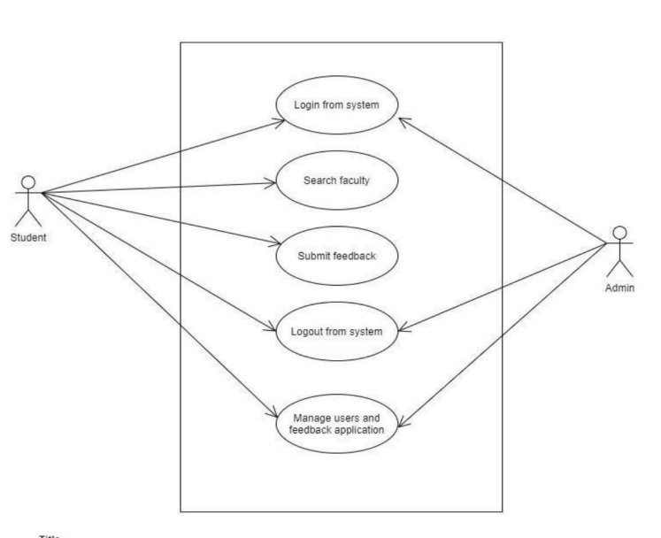

**Figure 4.1 Block Diagram**

**4.2 Project Description:**

The control flow is drawn from one operation to another. This flow can be sequential, branched, or concurrent. Activity diagrams deal with all type of flow control by using different elements such as fork, join, etc. The basic purposes of activity diagrams are similar to other four diagrams. It captures the dynamic behavior of the system. Other four diagrams are used to show the message flow from one object to another but activity diagram is used to show message flow from one activity to another. Activity is a particular operation of the system. Activity diagrams are not only used for visualizing the dynamic nature of a system, but they are also used to construct the executable system by using forward and reverse engineering techniques. The only missing thing in the activity diagram is the message part. It does not show any message flow from one activity to another. Activity diagram is sometimes considered as the flowchart. Although the diagrams look like a flowchart, they are not. It shows different flows such as parallel, branched, concurrent, and single. This is the login Activity Diagram of Student Feedback System, which shows the flows of login activity, where admin will be able to login using their user name and password. After login user can manage all the operations on Class, Feedback, Student, Teacher.All the pages such as Feedback, Faculty, and Student are secure and user can access these page after login. The three diagrams below help demonstrate how login page works in a Student Feedback System. The various objects in Student, Class, Feedback and Faculty page--interact over the course of activity, and the user will not be able to access this page without verifying their identity.

**4.3 Class Diagram**

Class diagram is a static diagram. A Class diagram in the Unified Modeling Language (UML) is a type of static structure diagram that describes the structure of a system by showing the system's classes, their attributes, operations (or methods), and the relationships among objects It represents the static view of an application. Class diagram is not only used for visualizing, describing, and documenting different aspects of a system but also for constructing executable code of the software application. Class diagram describes the attributes and operations of a class and also the constraints imposed on the system. The class diagrams are widely used in the modeling of object-oriented systems because they are the only UML diagrams, which can be mapped directly with object-oriented languages..

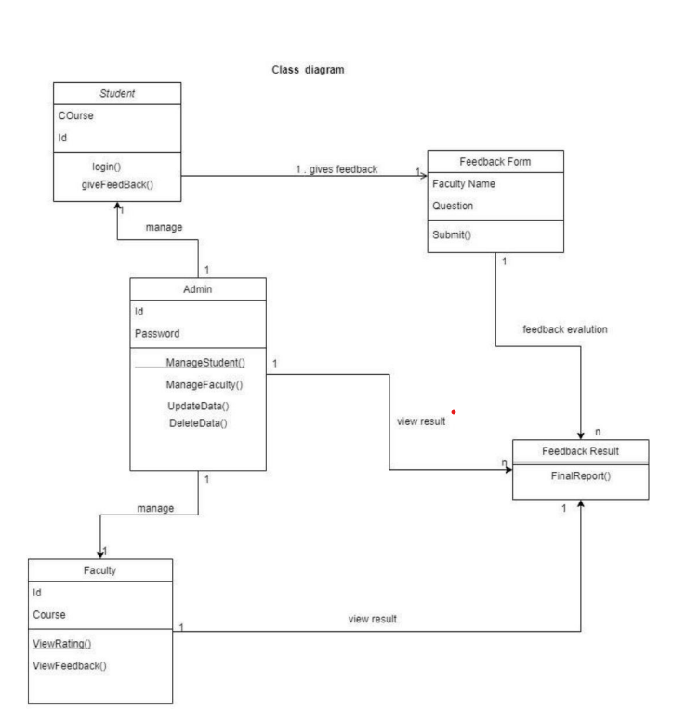

**Figure 4.3 Class Diagram**

**Modules**

**Description**

**Chapter 5**

**Modules Description**

.

**5.1 Data Collection Module**

Describe how the Data Collection Module gathers real-time sensor data from crop fields using IoT sensors. Explain the types of data collected and the sensors involved.Specify the types of IoT sensors used (e.g., humidity, temperature, image sensors).Mention how data is transmitted to the cloud (e.g., wireless protocols).

**5.2 Disease Detection Module**

Discuss how the Disease Detection Module analyzes the collected data using machine learning techniques to identify crop diseases. Highlight the importance of early disease detection. Share any specific accuracy rates or success stories related to disease identification. Emphasize the role of rapid disease detection in minimizing crop losses.

**5.3 Alert and Notification Module**

Explain how the Alert and Notification Module triggers alerts when diseases are detected. Mention the communication channels used for notifications. Detail the criteria for triggering alerts (e.g., disease severity thresholds). Discuss the various notification methods used to alert users. Highlight the importance of timely alerts for proactive action.

**5.4 Remote Monitoring Module**

Discuss the capabilities of the Remote Monitoring Module for real-time data access and decision-making. Explain how remote monitoring benefits crop producers. Provide examples of how remote monitoring has benefited crop producers (e.g., case studies). Discuss the significance of real-time data access for making informed decisions. Mention any remote control features, if applicable.

**5.5 User Interface Module**

The User Interface Module in our project, "Leaf Disease Detection Using Cropcare++," provides a user-friendly way for farmers to interact with the system. It's like the control center where farmers can access real-time data about their crops, receive alerts about diseases, and get recommendations on what to do. This simple and intuitive interface empowers farmers to make informed decisions easily, ensuring their crops stay healthy and productive.

**RESULTS AND**

**DISCUSSION**

**Chapter 6**

**Results and Discussion**

Firstly, there’s admin module which has admin login portal. The username and password of admin is initially fixed. After login, Admin views the students as well as faculty accounts and can modify their details. The whole data is stored in the database. The admin also adds the students and faculty details in the database. The admin also can delete the student’s as well as the faculty data. The admin can view all the feedbacks results present in the database. The identity of the student who gave the feedback is given by the admin. Then there’s student module which has student login portal. Each and every valid student has their unique username and password which is given by admin. The username and password when entered are checked with data present in the database. After login, the student can view the subject’s feedback which he/she wants to submit. Then in the feedback form, the name of the faculty automatically comes who teaches that particular subject. In the feedback form, there are multiple fields for which student has to show his opinion. The fields are Vocabulary and Body language, Audibility, Explanation, Subject Command etc., after the submission of feedback the answers of all the questions are analyzed and the result is stored in database. If the student has already given the feedback of that particular teacher, then he/she can’t give the feedback again. Then at last there’s faculty module which has teacher login portal. Each and every faculty has their unique username and password which is given by the admin. The username and password when entered are checked with data present in the database. The faculty can view their overall performance according to the student’s feedback. And student’s identity is not revealed to the faculty. There will be a graphical representation of student's feedback so that faculty can clearly understand his/her strengths.

**6.1 Login Page**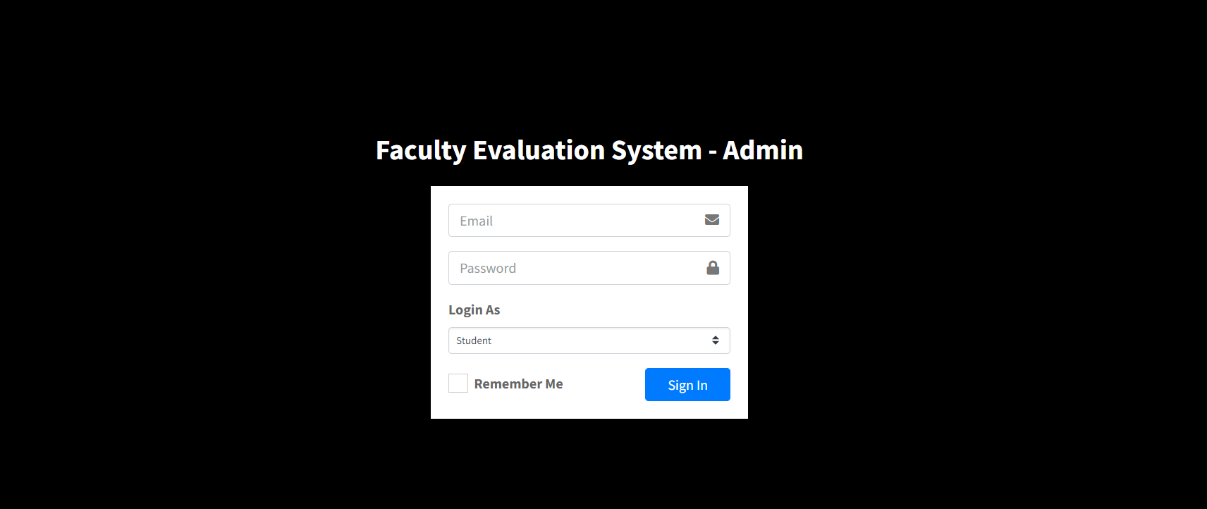

**Figure 6.1 Login Page**

**7.2 Admin Home Page**

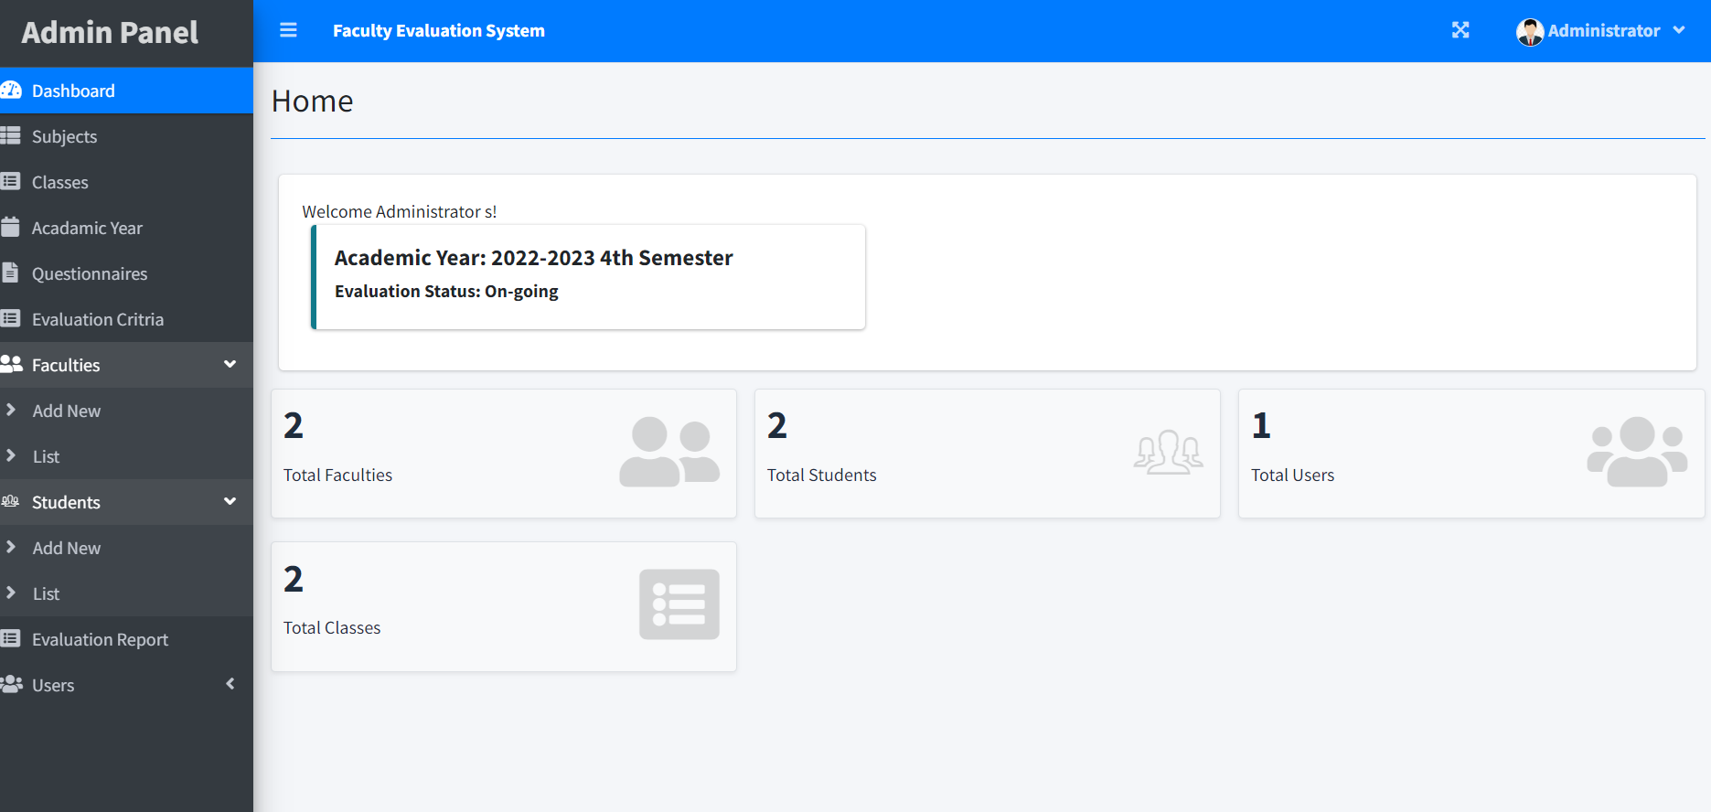

**Figure 6.2 Admin Home Page**

**6.3 Staff Page**

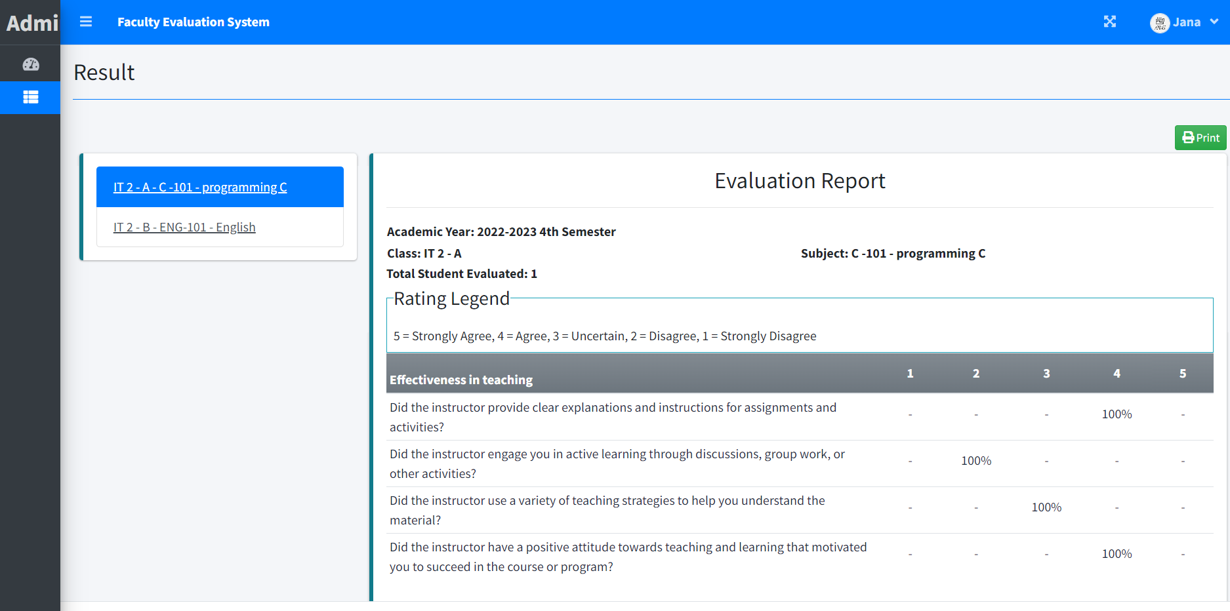

**Figure 6.3 Staff Page**

**6.4 Student Page**

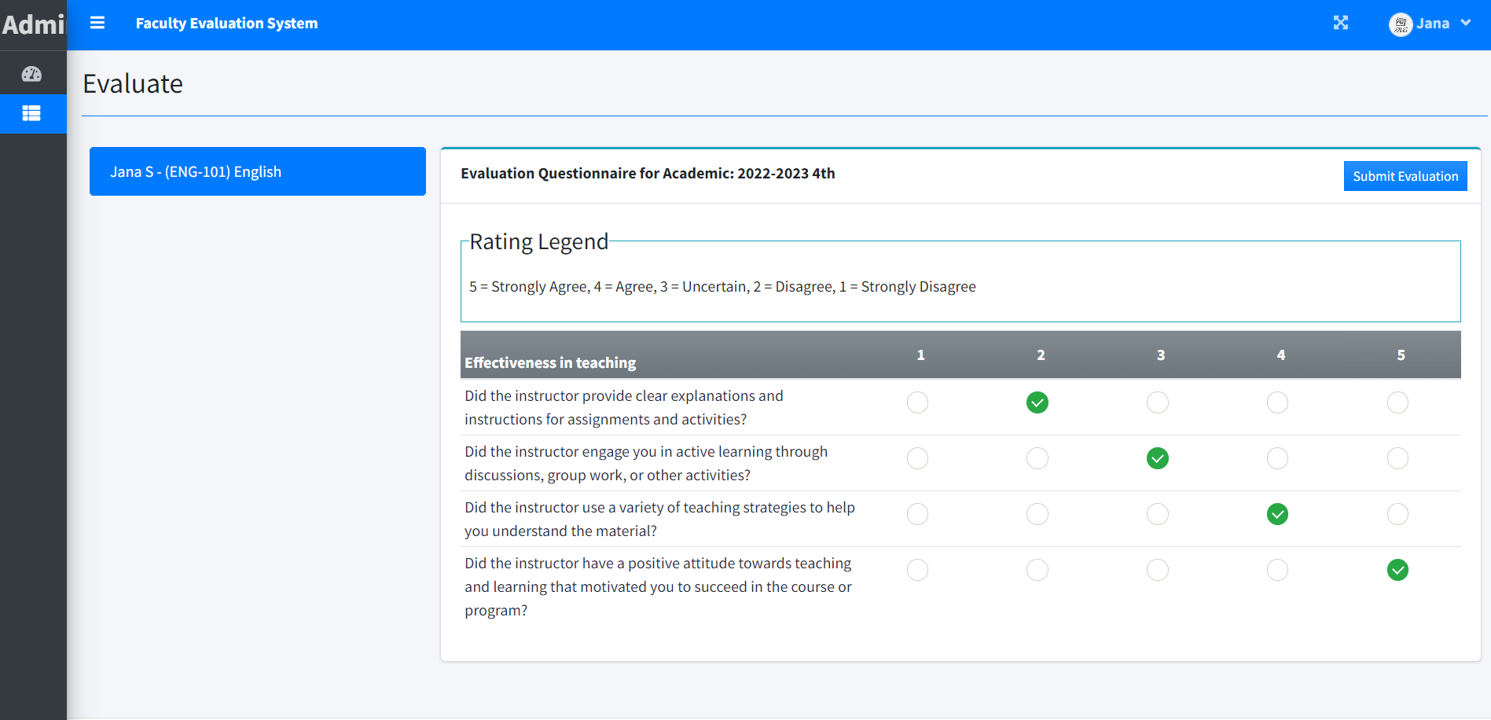

**Figure 6.4 Student Page**

**Sample Codes**

**Front End**

**Chapter 7**

**Sample Codes -Front End**

**<!DOCTYPE html>**

**<html lang="en">**

**<?php session_start() ?>**

**<?php**

**if(!isset($_SESSION['login_id']))**

**header('location:login.php');**

**include 'db_connect.php';**

**ob_start();**

**if(!isset($_SESSION['system'])){**

**$system = $conn->query("SELECT * FROM system_settings")->fetch_array();**

**foreach($system as $k => $v){**

**$_SESSION['system'][$k] = $v;**

**}**

**}**

**ob_end_flush();**

**include 'header.php'**

**?>**

**<body class="hold-transition sidebar-mini layout-fixed layout-navbar-fixed layout-footer-fixed">**

**<div class="wrapper">**

**<?php include 'topbar.php' ?>**

**<?php include $_SESSION['login_view_folder'].'sidebar.php' ?>**

**<!-- Content Wrapper. Contains page content -->**

**<div class="content-wrapper">**

**<div class="toast" id="alert_toast" role="alert" aria-live="assertive" aria-atomic="true">**

**<div class="toast-body text-white">**

**</div>**

**</div>**

**<div id="toastsContainerTopRight" class="toasts-top-right fixed"></div>**

**<!-- Content Header (Page header) -->**

**<div class="content-header">**

**<div class="container-fluid">**

**<div class="row mb-2">**

**<div class="col-sm-6">**

**</div><!-- /.col -->**

**</div><!-- /.row -->**

**<hr class="border-primary">**

**</div><!-- /.container-fluid -->**

**</div>**

**<!-- /.content-header -->**

**<!-- Main content -->**

**<section class="content">**

**<div class="container-fluid">**

**<?php**

**$page = isset($_GET['page']) ? $_GET['page'] : 'home';**

**if(!file_exists($_SESSION['login_view_folder'].$page.".php")){**

**include '404.html';**

**}else{**

**include $_SESSION['login_view_folder'].$page.'.php';**

**}**

**?>**

**</div><!--/. container-fluid -->**

**</section>**

**<!-- /.content -->**

**<div class="modal fade" id="confirm_modal" role='dialog'>**

**<div class="modal-dialog modal-md" role="document">**

**<div class="modal-content">**

**<div class="modal-header">**

**<h5 class="modal-title">Confirmation</h5>**

**</div>**

**<div class="modal-body">**

**<div id="delete_content"></div>**

**</div>**

**<div class="modal-footer">**

**<button type="button" class="btn btn-primary" id='confirm' onclick="">Continue</button>**

**<button type="button" class="btn btn-secondary" data-dismiss="modal">Close</button>**

**</div>**

**</div>**

**</div>**

**</div>**

**<div class="modal fade" id="uni_modal" role='dialog'>**

**<div class="modal-dialog modal-md" role="document">**

**<div class="modal-content">**

**<div class="modal-header">**

**<h5 class="modal-title"></h5>**

**</div>**

**<div class="modal-body">**

**</div>**

**<div class="modal-footer">**

**<button type="button" class="btn btn-primary" id='submit' onclick="$('#uni_modal form').submit()">Save</button>**

**<button type="button" class="btn btn-secondary" data-dismiss="modal">Cancel</button>**

**</div>**

**</div>**

**</div>**

**</div>**

**<div class="modal fade" id="uni_modal_right" role='dialog'>**

**<div class="modal-dialog modal-full-height modal-md" role="document">**

**<div class="modal-content">**

**<div class="modal-header">**

**<h5 class="modal-title"></h5>**

**<button type="button" class="close" data-dismiss="modal" aria-label="Close">**

**<span class="fa fa-arrow-right"></span>**

**</button>**

**</div>**

**<div class="modal-body">**

**</div>**

**</div>**

**</div>**

**</div>**

**<div class="modal fade" id="viewer_modal" role='dialog'>**

**<div class="modal-dialog modal-md" role="document">**

**<div class="modal-content">**

**<button type="button" class="btn-close" data-dismiss="modal"><span class="fa fa-times"></span></button>**

**<img src="" alt="">**

**</div>**

**</div>**

**</div>**

**</div>**

**</body>**

**</html>**

**Sample Codes**

**Back End**

**Chapter 8**

**Sample Codes Backend**

CREATE TABLE `evaluation_list` (

`evaluation_id` int(30) NOT NULL,

`academic_id` int(30) NOT NULL,

`class_id` int(30) NOT NULL,

`student_id` int(30) NOT NULL,

`subject_id` int(30) NOT NULL,

`faculty_id` int(30) NOT NULL,

`restriction_id` int(30) NOT NULL,

`date_taken` datetime NOT NULL DEFAULT current_timestamp()

) ENGINE=InnoDB DEFAULT CHARSET=utf8mb4;

INSERT INTO `evaluation_list` (`evaluation_id`, `academic_id`, `class_id`, `student_id`, `subject_id`, `faculty_id`, `restriction_id`, `date_taken`)

CREATE TABLE `faculty_list` (

`id` int(30) NOT NULL,

`school_id` varchar(100) NOT NULL,

`firstname` varchar(200) NOT NULL,

`lastname` varchar(200) NOT NULL,

`email` varchar(200) NOT NULL,

`password` text NOT NULL,

`avatar` text NOT NULL DEFAULT 'no-image-available.png',

`date_created` datetime NOT NULL DEFAULT current_timestamp()

) ENGINE=InnoDB DEFAULT CHARSET=utf8mb4;

INSERT INTO `faculty_list` (`id`, `school_id`, `firstname`, `lastname`, `email`, `password`, `avatar`, `date_created`) VALUES

CREATE TABLE `question_list` (

`id` int(30) NOT NULL,

`academic_id` int(30) NOT NULL,

`question` text NOT NULL,

`order_by` int(30) NOT NULL,

`criteria_id` int(30) NOT NULL

) ENGINE=InnoDB DEFAULT CHARSET=utf8mb4;

INSERT INTO `question_list` (`id`, `academic_id`, `question`, `order_by`, `criteria_id`) VALUES

(1, 3, 'Sample Question', 0, 1),

(3, 3, 'Test', 2, 2),

(5, 0, 'Question 101', 0, 1),

(6, 3, 'Sample 101', 4, 1);

CREATE TABLE `student_list` (

`id` int(30) NOT NULL,

`school_id` varchar(100) NOT NULL,

`firstname` varchar(200) NOT NULL,

`lastname` varchar(200) NOT NULL,

`email` varchar(200) NOT NULL,

`password` text NOT NULL,

`class_id` int(30) NOT NULL,

`avatar` text NOT NULL DEFAULT 'no-image-available.png',

`date_created` datetime NOT NULL DEFAULT current_timestamp()

) ENGINE=InnoDB DEFAULT CHARSET=utf8mb4;

CREATE TABLE `subject_list` (

`id` int(30) NOT NULL,

`code` varchar(50) NOT NULL,

`subject` text NOT NULL,

`description` text NOT NULL

) ENGINE=InnoDB DEFAULT CHARSET=utf8mb4;

INSERT INTO `subject_list` (`id`, `code`, `subject`, `description`) VALUES

(1, '101', 'Sample Subject', 'Test 101'),

(2, 'ENG-101', 'English', 'English'),

(3, 'M-101', 'Math 101', 'Math - Advance Algebra ');

CREATE TABLE `system_settings` (

`id` int(30) NOT NULL,

`name` text NOT NULL,

`email` varchar(200) NOT NULL,

`contact` varchar(20) NOT NULL,

`address` text NOT NULL,

`cover_img` text NOT NULL

) ENGINE=InnoDB DEFAULT CHARSET=utf8mb4;

INSERT INTO `system_settings` (`id`, `name`, `email`, `contact`, `address`, `cover_img`) VALUES

(1, 'Faculty Evaluation System', 'info@sample.comm', '+6948 8542 623', '2102 Caldwell Road, Rochester, New York, 14608', '');

CREATE TABLE `users` (

`id` int(30) NOT NULL,

`firstname` varchar(200) NOT NULL,

`lastname` varchar(200) NOT NULL,

`email` varchar(200) NOT NULL,

`password` text NOT NULL,

`avatar` text NOT NULL DEFAULT 'no-image-available.png',

`date_created` datetime NOT NULL DEFAULT current_timestamp()

) ENGINE=InnoDB DEFAULT CHARSET=utf8mb4;

INSERT INTO `users` (`id`, `firstname`, `lastname`, `email`, `password`, `avatar`, `date_created`)

**CONCLUSION**

# Chapter 9

# CONCLUSION AND FUTURE SCOPE

The Student Feedback System portal is developed to facilitate easy processing of Feedback in educational institutions. Manually, this consumes a lot of time, effort and paper work. The project “student feedback system” is designed in order reduce the burden of maintaining bulk of records. The feedback details of student are easy. It is compared to the manual feedback & storing maintaining the project is also easy which can is easily understandable. Maintaining the details in the database is manageable. In this paper we have discussed about the sentiment analysis in detail. Sentiment Analysis deals with evaluating whether this expressed opinion about the entity has a positive or a negative orientation. Sentiment Analysis problem has been a research interest for recent years. Sentimental analysis is an emerging field of data mining used to extract the knowledge from a huge volume of customer comments, feedback and reviews on any product or topic etc. A lot of work in opinion mining in customer reviews has been conducted to mine opinions in form of document, sentence and feature level sentiment analysis. In future, Sentiment analysis can be carried out on set of discovered feature expressions extracted from reviews. The Sentiment analysis and in natural language processing community, Sentiment Analysis become a most interesting research area. A more innovative and effective techniques needed to be invented which should overcome the current challenges faced by Sentiment Analysis. Although several notable works have come in this field, a fully automated and highly efficient system has not been introduced till now. problems have to be tackled separately and those solutions can be used to improve the methods to do sentiment analysis.

**REFERENCES**

# Chapter 10

# References

**[1]** Tanvi Hardeniya, Dilipkumar A.Borikar “Dictionary-Based approach to Sentiment analysis”,pp.may,2016.

**[2]** R Mehana,"Student feedback mining system adopting sentiment analysis",https://ijcat.com/archives/volume6/issue1/ij catr06011009.pdf

**[3]** A. Rashid, “Feature level opinion mining of educational student feedback data using sequential pattern mining and association rule mining,”

**[4]** Z Nasim, Q Rajput, S Haider. “Sentiment Analysis of Student Feedback Using Machine Learning and Lexicon Based Approaches”

**[5]** Sajjad Haider and Sayeed Ghani “Lexicon-Based Sentiment Analysis of Teachers’ Evaluation”, pp.october, 2016.

**[6]** A. Sagum, Jessiree Grace M. de Vera, Prince John S. Lansang, Danica Sharon R. Narciso and Jahren K. Respeto, “Application of Language Modelling in Sentiment Analysis for Faculty Comment Evaluation,” Proceedings of the International Multi Conference of Engineers and Computer Scientists

**[7]** H. Saif, M. Fernandez, Y. He, and H. Alani, “Evaluation datasets for twitter sentiment analysis,” in Proceedings of the 1st International Workshop on Emotion and Sentiment in Social and Expressive